**Experiment no: 07**

**Date: 03.09.2025**

Data Visualization using Tableau

# Aim:

To create interactive dashboards and visualizations using Tableau for better data understanding and insights.

# Objective:

To explore data visualization techniques in Tableau by connecting to different data sources, applying calculated fields, and developing insightful dashboards.

# Tools Used:

Tableau Desktop

# Dataset Description:

A small HR dataset containing details such as job titles, departments, gender, education level, work hours, projects handled, and performance scores.

The dataset is used to analyze workforce distribution, performance trends, and overtime patterns.

# Procedure:

1. Open Tableau and connect to the dataset (Excel/CSV format).
2. Load the data and explore available fields.
3. Create visualizations including bar charts, scatter plots, and tree maps.
4. Use calculated fields for custom metrics (e.g., total overtime or average performance).
5. Combine all visuals into a single dashboard with filters and legends for interactivity.
6. Format the dashboard for clarity and visual appeal.

# Dashboard Design:

The Tableau dashboard presents HR insights with clear and interactive visuals. It highlights

* + Overtime trends by job title
  + Department team size
  + Performance by education level
  + Relationship between projects handled and working hours.

The clean design, color consistency, and layout ensure easy interpretation of data.

**Output:**

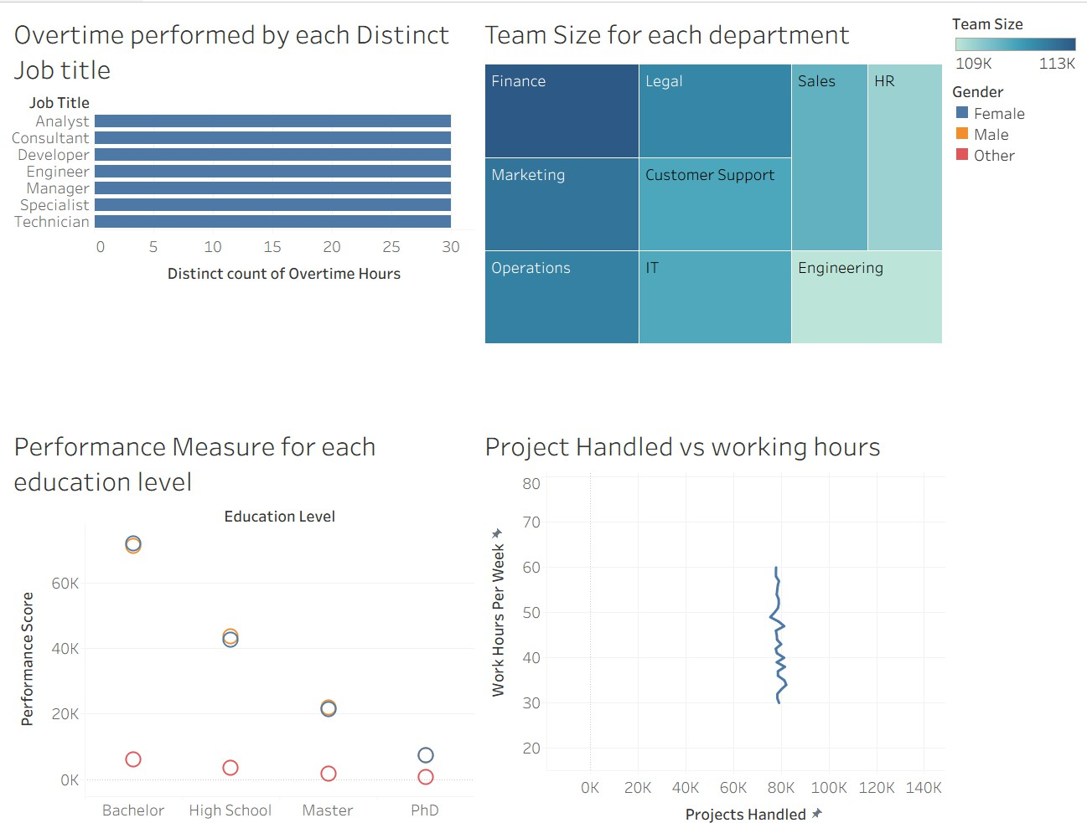

# Result:

An interactive Tableau dashboard was successfully created to visualize employee-related metrics, making it easier to analyze workforce trends and performance.

Conclusion:

This experiment demonstrates how Tableau simplifies complex data analysis through dynamic visualizations and dashboards, aiding data-driven decision-making**.**